1. a)

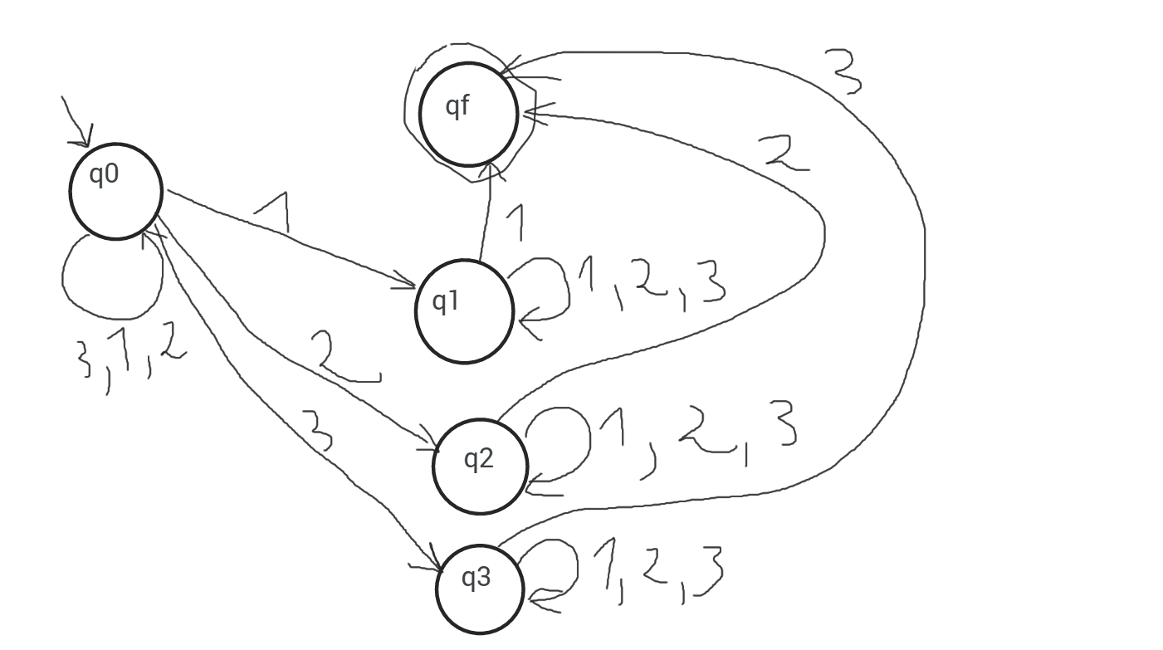

Prove that w = 12321 in L(M)

w = 12321 ϵ L(M)? **is accepted**

(q0,12321) Ͱ (q1,2321) Ͱ (q1,321) Ͱ (q1,21) Ͱ (g1,1) Ͱ (qf, ɛ)

w = 2321 ϵ L(M)? **is not accepted**

(q0,2321) Ͱ (q2,321) Ͱ (q2,21) Ͱ (q2,1) Ͱ (q2, ɛ)

We did not reach a final state so we try again

(q0,2321) Ͱ (q0,321) Ͱ (q0,21) Ͱ (q2,1) Ͱ (q2, ɛ) – same thing

1. b)

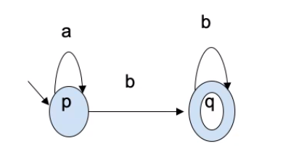

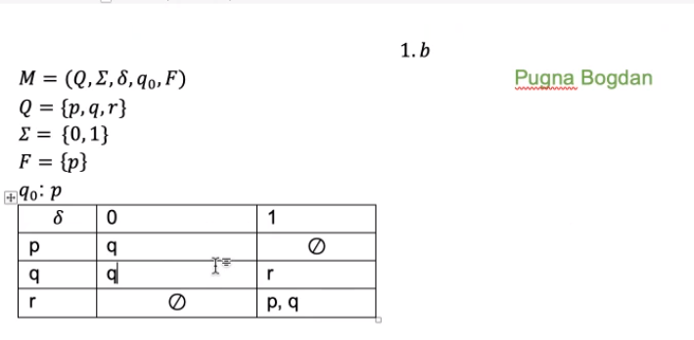

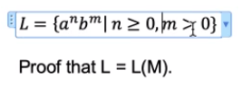

1. L L(M)

2. L(M) L





